Concentric Shapes
# Source: AI Source: Provided by: [Data Path: Persons Table -> ID Column: 1, Name_En Column: Motasem Essam] -> From: [ChatGPT] on [7/25/2026]
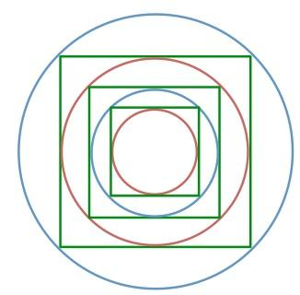
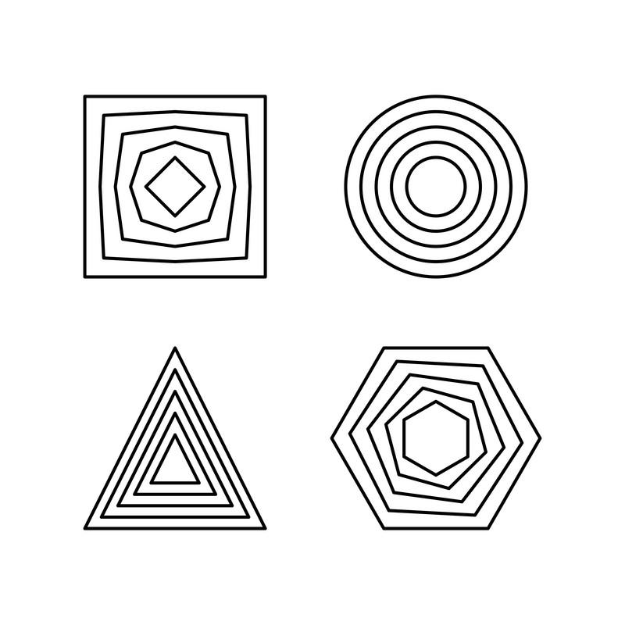
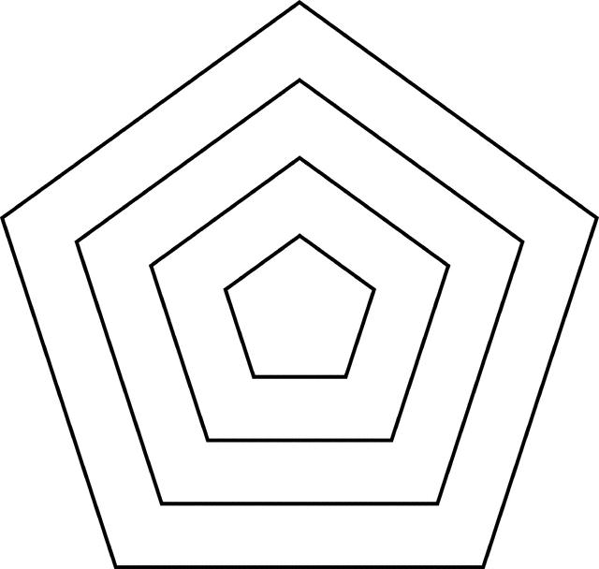
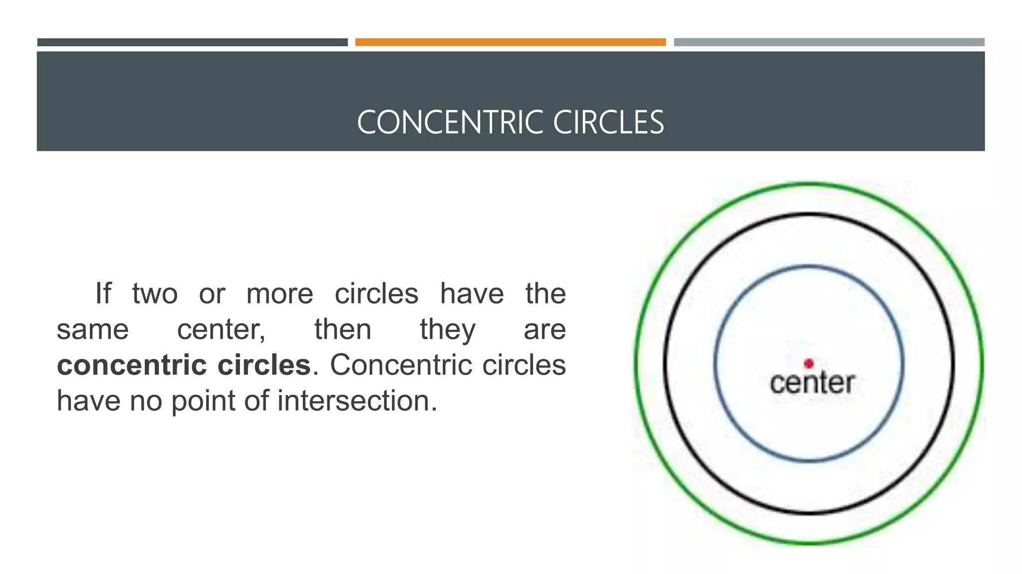
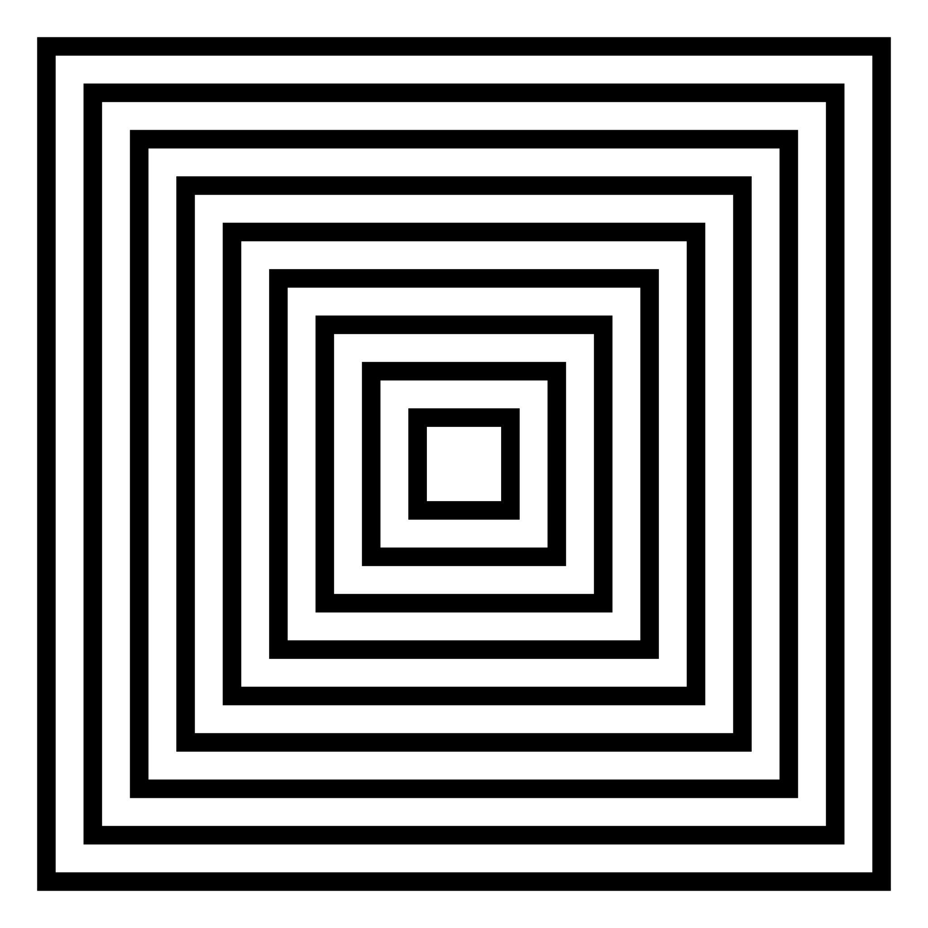
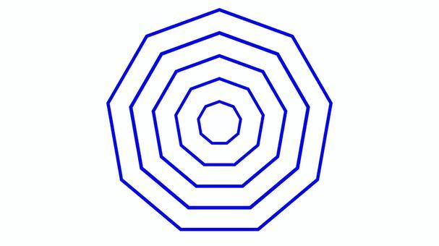

Definition
# Source: AI Source: Provided by: [Data Path: Persons Table -> ID Column: 1, Name_En Column: Motasem Essam] -> From: [ChatGPT] on [7/25/2026]
Concentric Shapes are two or more shapes that share the same center or same central point, while having different sizes or boundaries.
The term concentric comes from the idea of having a common center.
The most familiar example is a set of circles with the same center:
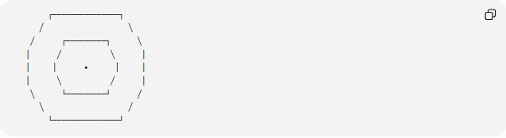
┌───────────────┐
╱ ╲
╱ ┌─────────┐ ╲
│ ╱ ╲ │
│ │ • │ │
│ ╲ ╱ │
╲ └─────────┘ ╱
╲ ╱
└───────────────┘

Fundamental Concept
# Source: AI Source: Provided by: [Data Path: Persons Table -> ID Column: 1, Name_En Column: Motasem Essam] -> From: [ChatGPT] on [7/25/2026]
The essential property of concentric shapes is:
$$\boxed{\text{Common Center}}$$
For concentric circles with center $O$:
$$O_{1}=O_{2}=O$$
but their radii can be different:
$$r_{1}≠r_{2}$$
For example:
$$r_{1}=3, r_{2}=6$$
Both circles have the same center but different sizes.

Main Characteristics
# Source: AI Source: Provided by: [Data Path: Persons Table -> ID Column: 1, Name_En Column: Motasem Essam] -> From: [ChatGPT] on [7/25/2026]
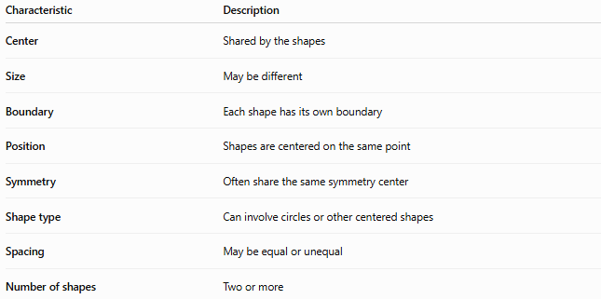
Characteristic | Description
Center | Shared by the shapes
Size | May be different
Boundary | Each shape has its own boundary
Position | Shapes are centered on the same point
Symmetry | Often share the same symmetry center
Shape type | Can involve circles or other centered shapes
Spacing | May be equal or unequal
Number of shapes | Two or more

Concentric Circles
# Source: AI Source: Provided by: [Data Path: Persons Table -> ID Column: 1, Name_En Column: Motasem Essam] -> From: [ChatGPT] on [7/25/2026]
The most important and standard example is concentric circles.
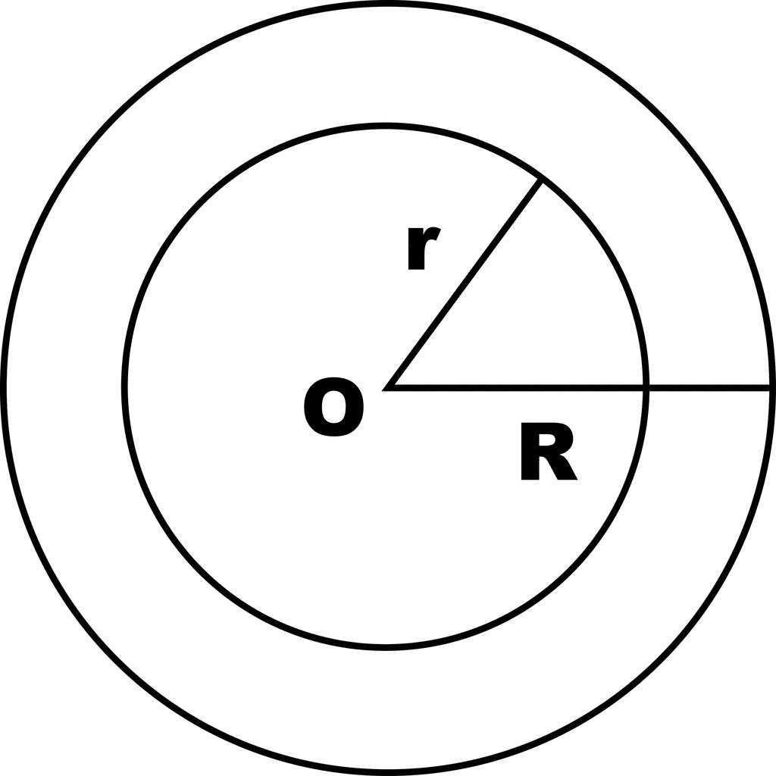
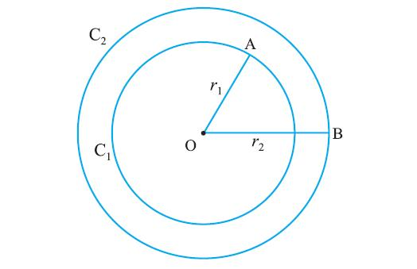
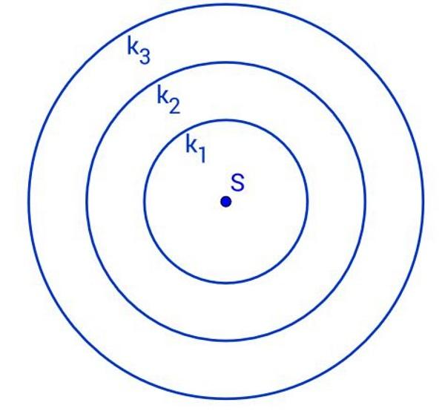
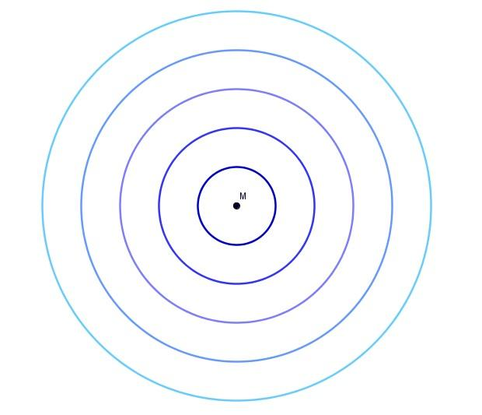
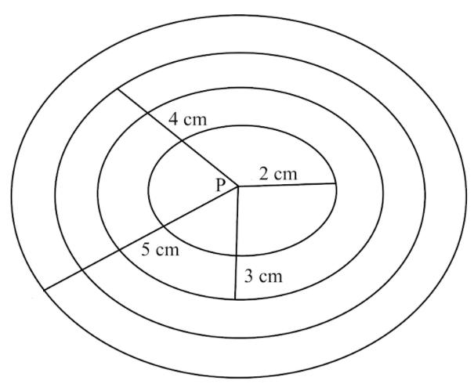
Suppose two circles have center $O$:
$$O_{1}=O_{2}=O$$
with radii:
$$r_{1}<r_{2}$$
Then the circles are concentric.
Their equations can be written as:
$${\left(x-h\right)}^{2}+{\left(y-k\right)}^{2}=r_{1}^{2}$$
and
$${\left(x-h\right)}^{2}+{\left(y-k\right)}^{2}=r_{2}^{2}$$
Both equations have the same center:
$$\left(h , k\right)$$

Types of Concentric Shapes
# Source: AI Source: Provided by: [Data Path: Persons Table -> ID Column: 1, Name_En Column: Motasem Essam] -> From: [ChatGPT] on [7/25/2026]
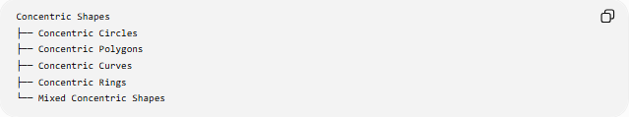
Concentric Shapes
├── Concentric Circles
├── Concentric Polygons
├── Concentric Curves
├── Concentric Rings
└── Mixed Concentric Shapes

1-Concentric Polygons
# Source: AI Source: Provided by: [Data Path: Persons Table -> ID Column: 1, Name_En Column: Motasem Essam] -> From: [ChatGPT] on [7/25/2026]
Two or more polygons can be arranged around the same center.
For example, two squares may share the same center:
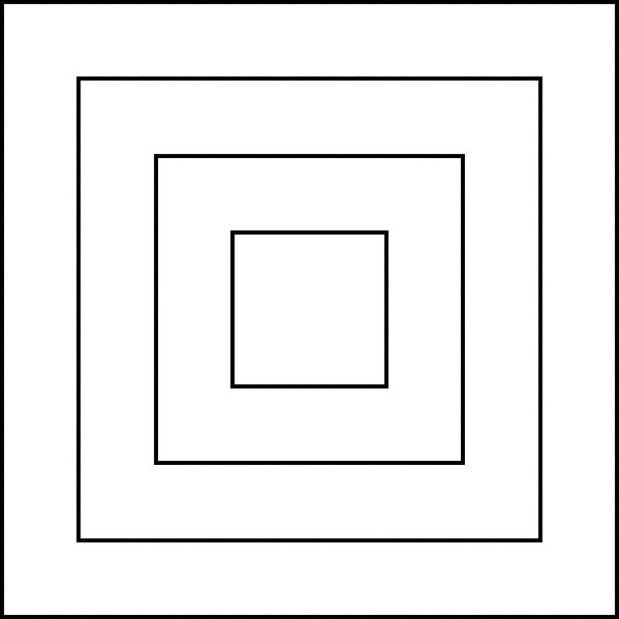
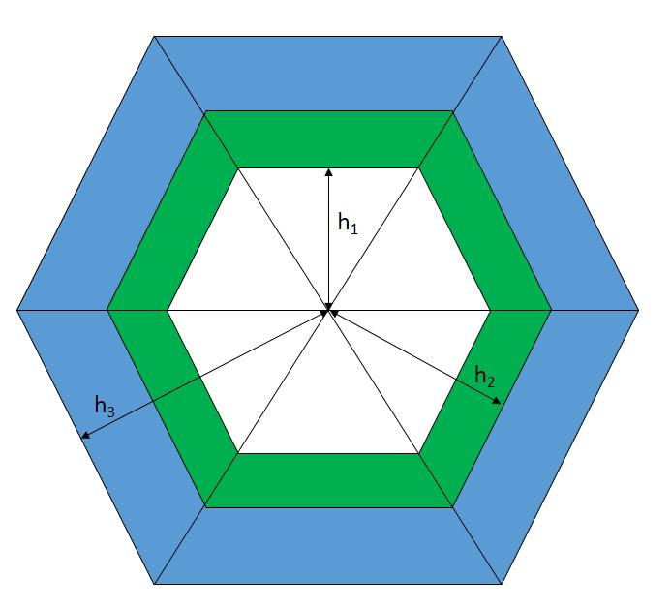
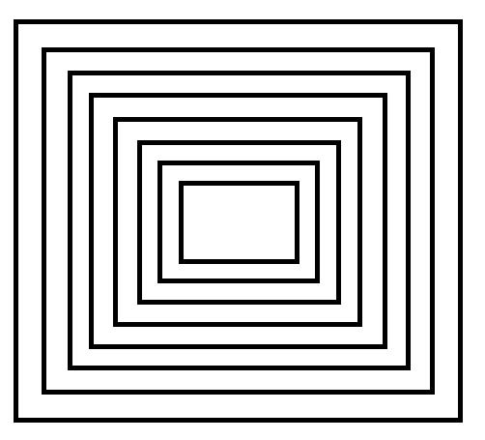
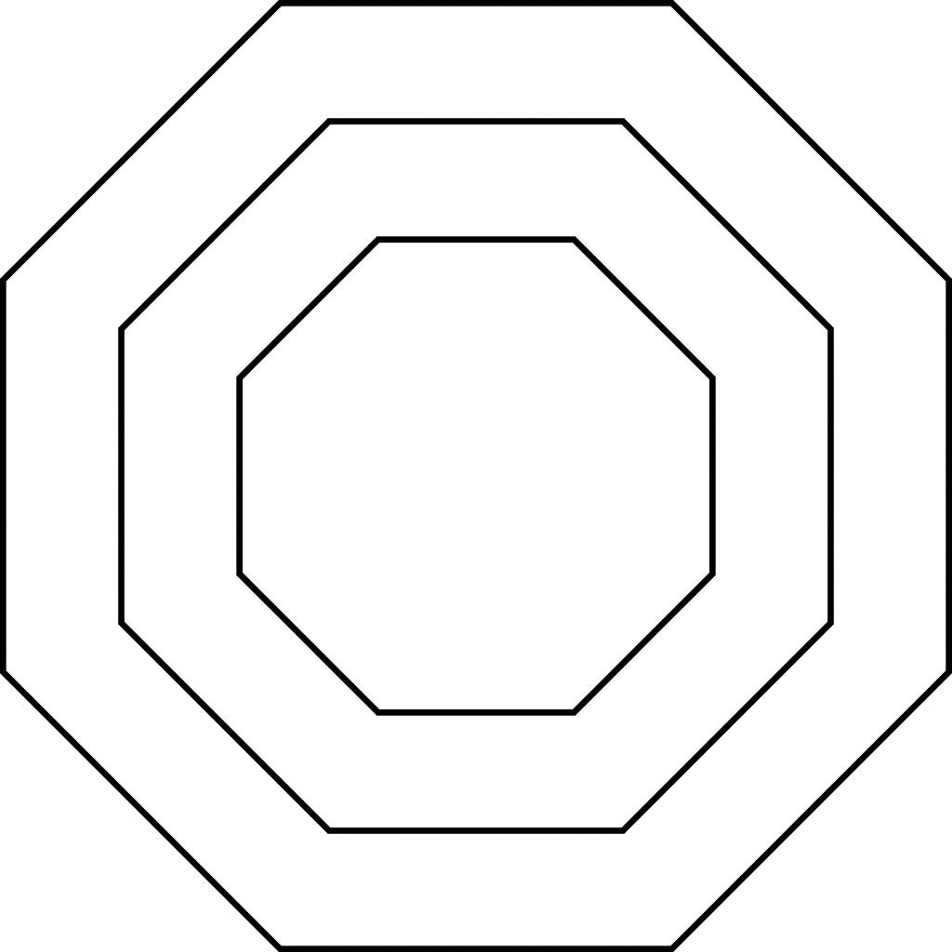
However, unlike circles, the term concentric polygons is less standardized. It generally describes polygons positioned so that they share a common center.
For regular polygons, this relationship is particularly clear.

2-Concentric Curves
# Source: AI Source: Provided by: [Data Path: Persons Table -> ID Column: 1, Name_En Column: Motasem Essam] -> From: [ChatGPT] on [7/25/2026]
Two or more curves can have a common center or central point.
For example, circular curves with different radii are concentric.
More generally, the term can be used descriptively for curves arranged around a common center.

3-Concentric Rings
# Source: AI Source: Provided by: [Data Path: Persons Table -> ID Column: 1, Name_En Column: Motasem Essam] -> From: [ChatGPT] on [7/25/2026]
A Concentric Ring is a region between two concentric boundaries.
For two concentric circles, the region between them is called an annulus.
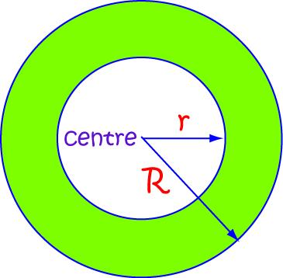
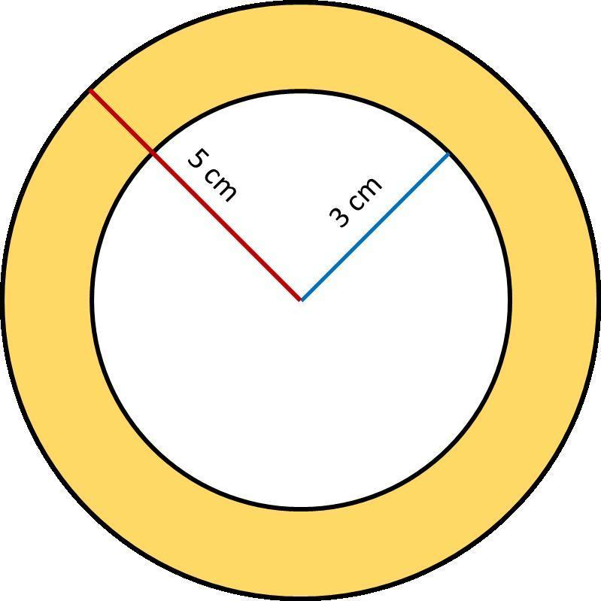
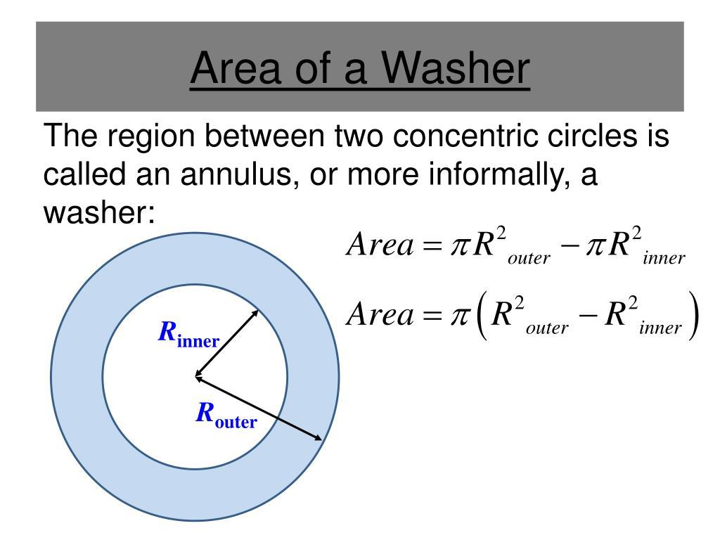
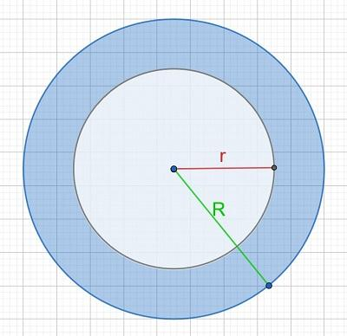
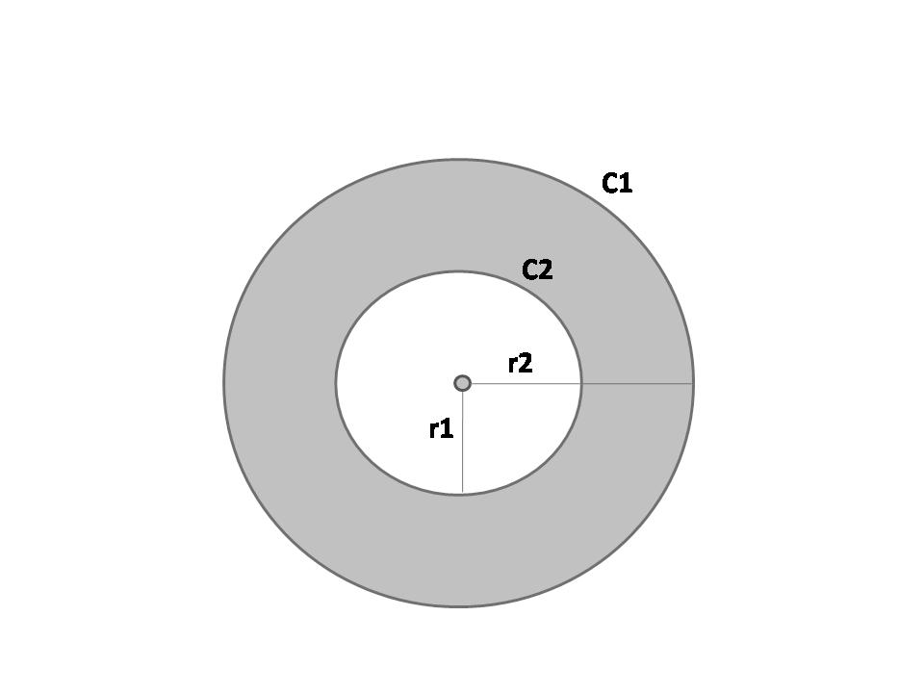
If the outer radius is $R$and inner radius is $r$:
$$\boxed{A=π\left(R^{2}-r^{2}\right)}$$

4-Mixed Concentric Shapes
# Source: AI Source: Provided by: [Data Path: Persons Table -> ID Column: 1, Name_En Column: Motasem Essam] -> From: [ChatGPT] on [7/25/2026]
Different types of shapes can sometimes be arranged around the same center.
For example:
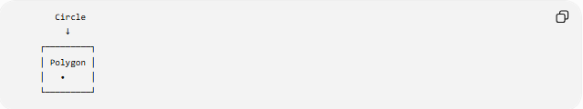
Circle
↓
┌─────────┐
│ Polygon │
│ • │
└─────────┘
This is best described as a concentric arrangement rather than treating "concentric" as a strict mathematical category for every possible shape combination.

Concentric vs Non-Concentric Shapes
# Source: AI Source: Provided by: [Data Path: Persons Table -> ID Column: 1, Name_En Column: Motasem Essam] -> From: [ChatGPT] on [7/25/2026]
Concentric

◯
◯ • ◯
◯
Both shapes share the same center.
Non-Concentric
◯ ◯
•
The shapes have different centers.
Therefore:
$$\boxed{\text{Same Center}⇒\text{Concentric}}$$
when the shapes are being considered in a context where a common center is defined.

Concentric Circles and Radii
# Source: AI Source: Provided by: [Data Path: Persons Table -> ID Column: 1, Name_En Column: Motasem Essam] -> From: [ChatGPT] on [7/25/2026]
For concentric circles:
$$r_{1}<r_{2}<r_{3}<⋯<r_{n}$$
while:
$$O_{1}=O_{2}=O_{3}=⋯=O_{n}$$
Thus, the centers are identical even though the radii are different.
The circumference of each circle is:
$$C=2πr$$
and its area is:
$$A=πr^{2}$$

Distance Between Concentric Circles
# Source: AI Source: Provided by: [Data Path: Persons Table -> ID Column: 1, Name_En Column: Motasem Essam] -> From: [ChatGPT] on [7/25/2026]
For two concentric circles with radii $R$and $r$, the radial distance between their circumferences is:
$$\boxed{d=R-r}$$
This distance is constant in every radial direction.
For example, if:
$$R=10, r=6$$
then:
$$d=10-6=4$$

Concentric Rings
# Source: AI Source: Provided by: [Data Path: Persons Table -> ID Column: 1, Name_En Column: Motasem Essam] -> From: [ChatGPT] on [7/25/2026]
For multiple concentric circles, several rings can be created:
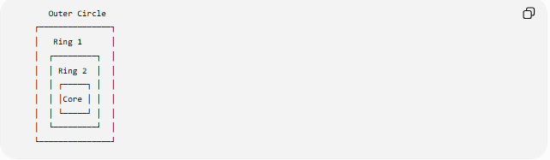
Outer Circle
┌───────────────┐
│ Ring 1 │
│ ┌─────────┐ │
│ │ Ring 2 │ │
│ │ ┌─────┐ │ │
│ │ │Core │ │ │
│ │ └─────┘ │ │
│ └─────────┘ │
└───────────────┘
Each adjacent pair of circles forms a ring.
For radii:
$$r_{1}<r_{2}<r_{3}$$
the ring areas are:
$$A_{1}=π\left(r_{2}^{2}-r_{1}^{2}\right) \\ A_{2}=π\left(r_{3}^{2}-r_{2}^{2}\right)$$

Concentric Shapes and Symmetry
# Source: AI Source: Provided by: [Data Path: Persons Table -> ID Column: 1, Name_En Column: Motasem Essam] -> From: [ChatGPT] on [7/25/2026]
Concentric shapes commonly share a common center of symmetry.
For concentric circles, the common center is a center of:
- Reflection symmetry
- Rotational symmetry
Every rotation about the common center leaves each circle unchanged.

Concentric vs Similar Shapes
# Source: AI Source: Provided by: [Data Path: Persons Table -> ID Column: 1, Name_En Column: Motasem Essam] -> From: [ChatGPT] on [7/25/2026]
These concepts are different.
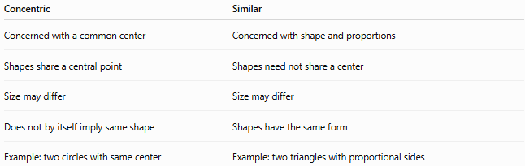
Concentric | Similar
Concerned with a common center | Concerned with shape and proportions
Shapes share a central point | Shapes need not share a center
Size may differ | Size may differ
Does not by itself imply same shape | Shapes have the same form
Example: two circles with same center | Example: two triangles with proportional sides
Two shapes can be both concentric and similar, but neither property requires the other.

Concentric vs Congruent Shapes
# Source: AI Source: Provided by: [Data Path: Persons Table -> ID Column: 1, Name_En Column: Motasem Essam] -> From: [ChatGPT] on [7/25/2026]
Concentric shapes do not have to be congruent.
For example:
$$r_{1}=3, r_{2}=6$$
The circles are concentric but not congruent.
Two concentric circles can be congruent only if their radii are equal. But if two circles have the same center and the same radius, they are actually the same circle, not two distinct concentric circles.

Mathematical Example
# Source: AI Source: Provided by: [Data Path: Persons Table -> ID Column: 1, Name_En Column: Motasem Essam] -> From: [ChatGPT] on [7/25/2026]
Suppose three circles have the common center:
$$O=\left(2 , 3\right)$$
and radii:
$$r_{1}=2, r_{2}=5, r_{3}=8$$
Their equations are:
$${\left(x-2\right)}^{2}+{\left(y-3\right)}^{2}=4 \\ {\left(x-2\right)}^{2}+{\left(y-3\right)}^{2}=25 \\ {\left(x-2\right)}^{2}+{\left(y-3\right)}^{2}=64$$
All three are concentric because they share the same center:
$$\boxed{O=\left(2 , 3\right)}$$

Classification Summary
# Source: AI Source: Provided by: [Data Path: Persons Table -> ID Column: 1, Name_En Column: Motasem Essam] -> From: [ChatGPT] on [7/25/2026]
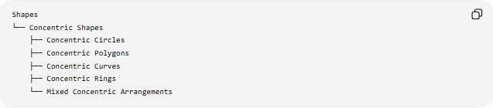
Shapes
└── Concentric Shapes
├── Concentric Circles
├── Concentric Polygons
├── Concentric Curves
├── Concentric Rings
└── Mixed Concentric Arrangements
The most important and standard case is:
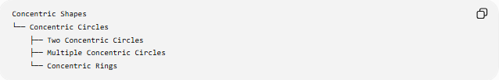
Concentric Shapes
└── Concentric Circles
├── Two Concentric Circles
├── Multiple Concentric Circles
└── Concentric Rings

Key Points
# Source: AI Source: Provided by: [Data Path: Persons Table -> ID Column: 1, Name_En Column: Motasem Essam] -> From: [ChatGPT] on [7/25/2026]
- Concentric shapes share a common center.
- Their sizes may be different.
- Concentric circles are the standard and most common example.
- For concentric circles:
$$O_{1}=O_{2}=⋯=O$$
- Different radii mean different-sized circles.
- The distance between two concentric circles is:
$$R-r$$
- The region between two concentric circles is an annulus.
- Annulus area:
$$π\left(R^{2}-r^{2}\right)$$
- Concentricity is different from similarity and congruence.
- "Concentric" is primarily a positional relationship, rather than a particular shape type.

Conclusion
# Source: AI Source: Provided by: [Data Path: Persons Table -> ID Column: 1, Name_En Column: Motasem Essam] -> From: [ChatGPT] on [7/25/2026]
Concentric Shapes are shapes arranged around a common center. The concept is most precisely and commonly applied to concentric circles, but the term can also describe polygons, curves, and other shapes arranged around the same central point. The key idea is the shared center, not necessarily identical shape or size.

